HOW to Replicate the GEVE- Ventilator setup.

Geneva, 17/04/20

Abstract :

This document presents a base line for those who would like to know more about the project or to replicate it. Most of the specific points relates to the external documentation, where more information can be found for each section.

Contents

The Electronics 2

Components 2

The control box 2

Electrical scheme for the Arduino 3

General Cabling principle 4

Mechanics 4

Motor used 4

Mechanical setup 4

Ambubag, pipes, and pressure sensor connection. 5

Sofware 5

Arduino Code 5

Optional LabVIEW Interface 5

# The Electronics

## Components

First you will have to get the different electrical components to build the control box.

Here is the components list that was bought from digikey.ch in our case.

|  |  |  |  |
| --- | --- | --- | --- |
| **DESCRIPTION** | **N Required** | **Digikey.ch Ref.** | **Manufacturer Ref.** |
| SENSOR PRES 160 MILLIBAR DIFF 5V | 1 | 480-5448-ND | SSCDRNN160MDAA5 |
| POT 10K OHM 1W PLASTIC LINEAR | 3 | 91A1A-B28-B15L-ND | 91A1A-B28-B15L |
| KNOB FLUTED W/SKIRT 0.250" PLAST | 3 | 679-3545-ND | MPKES90B14 |
| ARDUINO UNO R3 ATMEGA328P EVAL | 1 | 1050-1024-ND | A000066 |
| PROTO-SCREWSHIELD WINGSHIELD R3 | 2 | 1528-1047-ND | 196 |
| AUDIO MAGNETIC XDCR 1-6V SMD | 2 | 102-3746-1-ND | CMT-8540S-SMT-TR |
| Darlington driver | 1 | 497-2348-5-ND | ULN2064B |

In addition, you will need:

* some resistors ( 5x 5.6 kΩ, 4x 22kΩ, 1x 3.3 kΩ )
* a standard led component.
* a 9V power supply for the Arduino ( we used a 12V power supply from Meanwell were the output voltage can be adjusted and set it to the minimum which is about 10.8V. the Arduino should be able to handle up to 12V).
* a 24V power supply for the motor drive ( smc drive for linear motor in our case)
* The smc drive for the linear motor or your own motor driver
* a small LCD display for the Arduino type LCD2004A
* One push button for on/off action
* One toggle button for error reset.
* Some standards cabling stuff.

## The control box

For the demo setup, we placed all the electronics inside a standard plastic box and drilled holes on the top cover to place the buttons, knobs and the screen. And to pass cables out for the power supply, the usb cable to connect to the computer and the cables to the motor.

A wood plate was used as a support for the elements. We used a din rail to place the power supplies and some electrical dispatcher to dispatch 5V

Here are some pictures below that shows the box from the outside and from the inside.

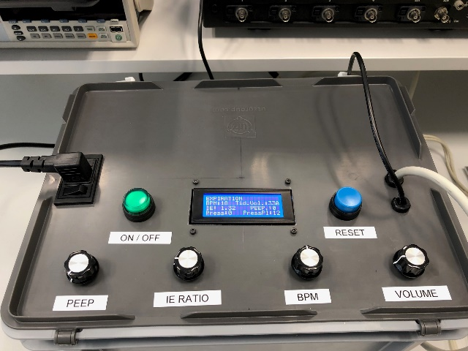 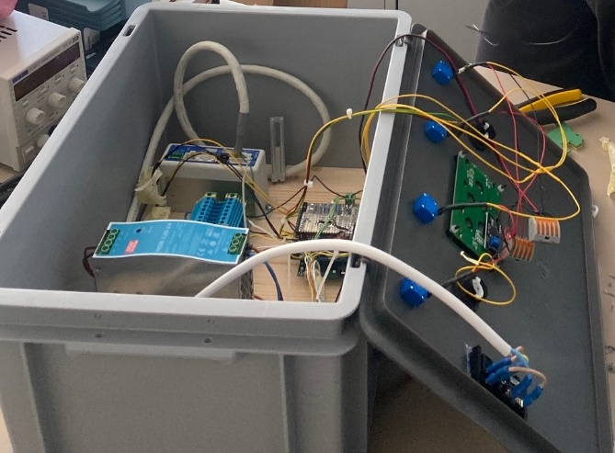

## Electrical scheme for the Arduino

Below is the electrical scheme to connect the Arduino to the other components. You can find a better quality version of the drawing in the additional documentation.

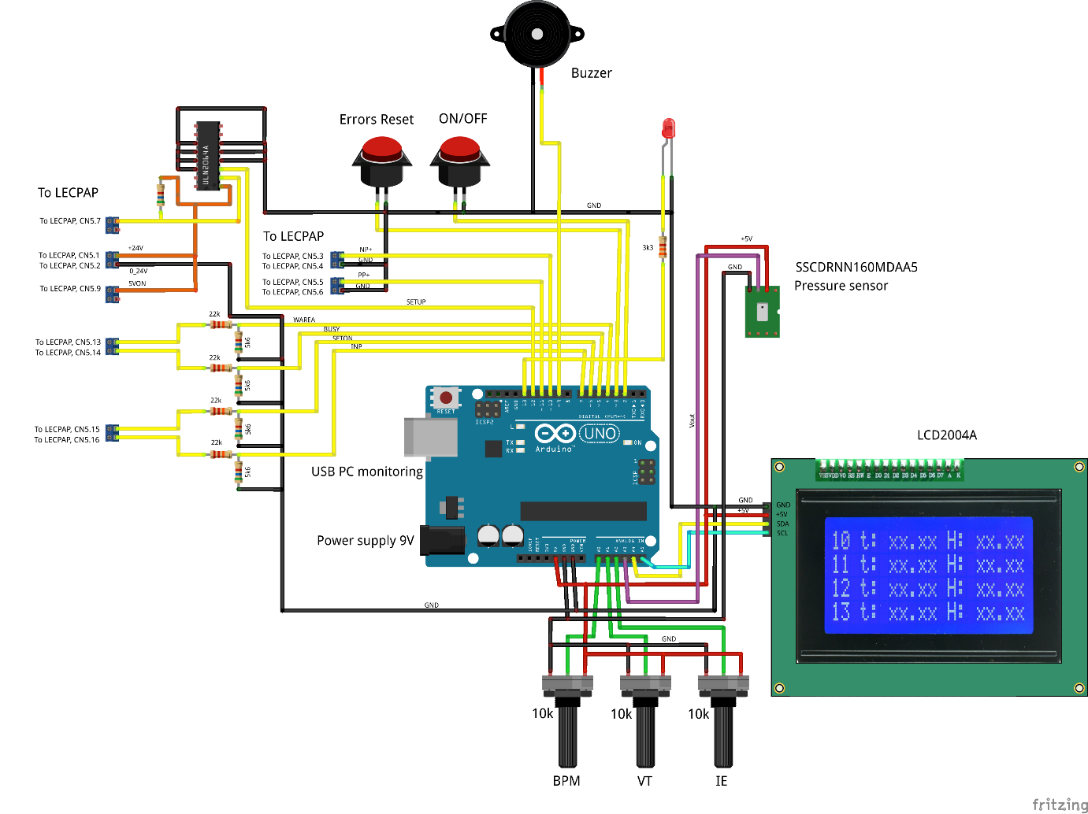

## General Cabling principle

# Mechanics

## Motor used

We used a linear motor drive from SMC as shown below.

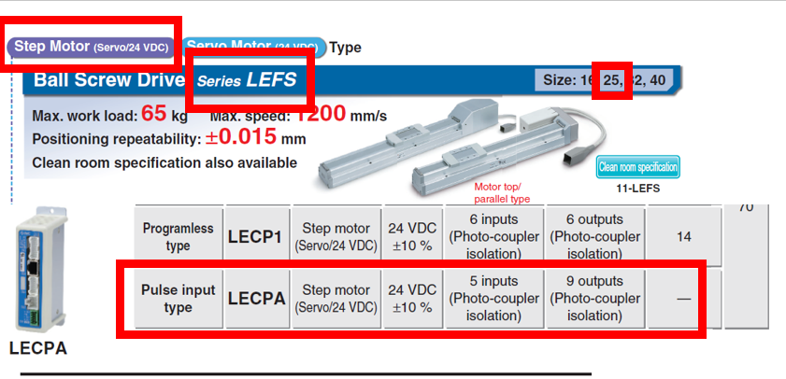

## Mechanical setup

We used a metallic plate as a support plate for the linear motor. Some 3D parts have been made to push the balloon. One side is fixed. The other one moves. All the CAD drawings are provided in the external documentation, as well as the files for 3D printing.

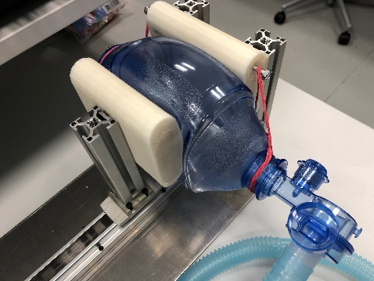 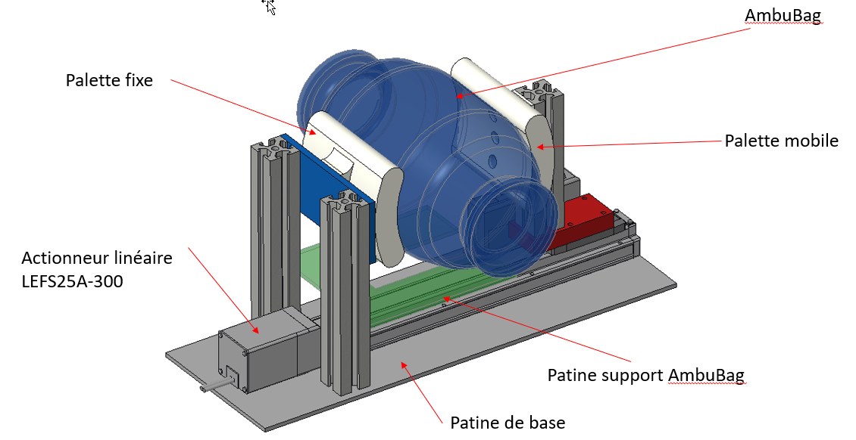

## Ambubag, pipes, and pressure sensor connection.

* The ambubag used is a standard 1.8L one bought from ambushop.ch
* The pipes, including the small one used to connect to the pressure are parts provided by HUG.
* For the pressure measurement a small plastic pipe connects the pressure sensor to the main pipe. An adaptor is used to fit the small pipe to the main one.

In addition, for testing the system, we bought a test lung from Dräger. Model SelfTestLung 1L. At the moment this documentation is written, we could not test the setup with it as it has not been delivered yet.

# Sofware

## Arduino Code

You can access the Arduino code in the external documentation. You will have to flash your Arduino with the code yourself.

## Optional LabVIEW Interface

An optional LabVIEW interface was made to offer the possibility to better visualize settings and data.

It acts only as a display and no settings can be made from it. The interface is totally optional and can added or removed at anytime without perturbing the system.

The communication is simple. The arduino outputs a string that contains all the data in it through serial communication, and the labVIEW interface reads it, decode it, and then display the information.

The code was developed in LV18. The source code is available in the LabVIEW folder of the project.

An executable is also provided, and can be used as it is. Nevertheless you will need to install the LabVIEW 18 Runtime from National Instruments website before behing able to run the code.

Runtime can be dowloaded here :

<https://www.ni.com/fr-ch/support/downloads/software-products/download.labview-runtime.html#309627>

Much more information about the LabVIEW code directly in the source code and in the Read.md document that you can find on the LabVIEW Code folder of Github.

